**How to make a Countdown Timer.**

This will show us how to make a timer.

1. **Creating a canvas**

Right-Click on the Hierarchy and Select “UI”, then pick “text”

1. **Creating a script**

Create a new C# script and name it “CountdownScript”.

Open your new script and delete both starting Functions “Start” and “Update”.

Under “using UnityEngine;” write “using UnityEngine.UI;”

Next write the following variables:

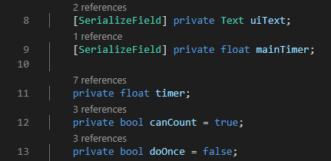

After you need to create a “Update” function and put the following “if” statements:

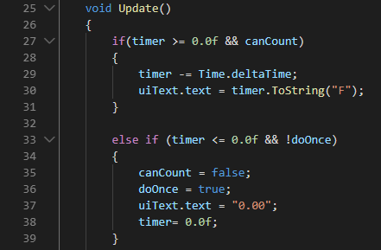

Next make a “Start” function and input the code below:

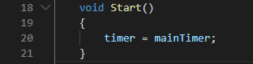

1. **Time Controller**

Go back into Unity and Right-Click the Hierarchy and create an “Empty GameObject”. Rename it to “TimerController”.

Add the “CountdownScript” to the “TimerController”, drag the “Text” from the UI and put it in the “TimerController”. You can also set the time to however long you wish.